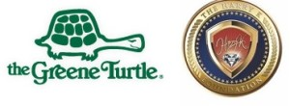

13th Annual Harry K Foundation 5k Run/Walk
Run to Fight Childhood Hunger in Delaware

July 24, 2022 – Sunday

Lewes, DE

For more information and registration

https://raceroster.com/events/2022/58197/13th-annual-harry-k-foundation-5k-runwalk

